

**Lab Mid Exam**

***Course Title* :**System Analysis& Design

***Course Code* :**CSE- 325

***Task Name* :**Use Case Diagram of a Banking Management System,

Class Diagramof an Online Shopping System.

**Submitted By:**

**ID :171442627**

**Name :Md. Emon Shahidullah**

**Program :CSE(Eve)**

**Batch : 44th**

**Date : 27-05-2019**

**Submitted To:**

Supta Richard Philip

Senior Lecturer, Department of CSE

City University,Bangladesh

*Use Case Diagram of a Banking Management System.*

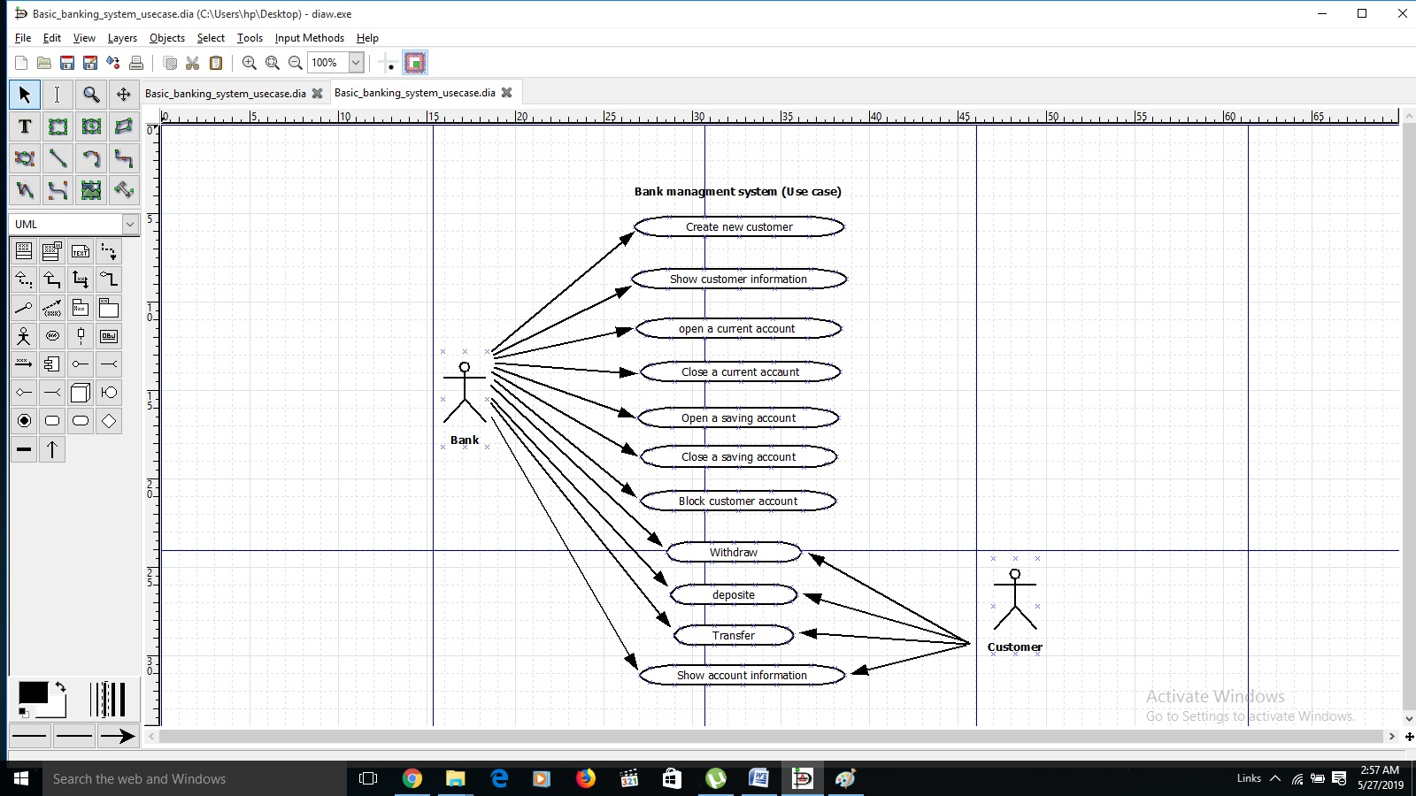

*Class Diagram of an Online Shopping System.****